Tring Lions Quiz (9)
. 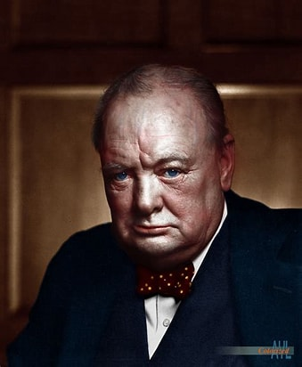
Prime Ministers
Presidents
and Poets
The answers to the 50 cryptic clues are the surnames (or aristocratic titles) of famous people. There are 27.5 UK Prime Ministers, 16.5 American Presidents and 6 English poets
For this quiz, to add to the excitement, we are offering prizes for the most correct answers, £20, £10 and £5. Equal scores will be drawn out of a hat
Please email your answers to Penny.tregillus@tringlions.org.uk or post them to Penny Tregillus, 33A Rock Lane, Leighton Buzzard, LU7 2QQ
Answers will be published on our website www.tringlions.org.uk on Wednesday 1st March
The charity we will be supporting with this quiz is ‘Small Acts of Kindness’.
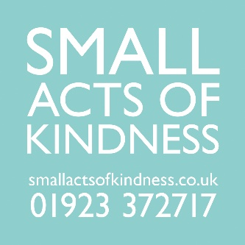
‘Small Acts of Kindness sources and distributes practical gifts and information that reduce the negative impact that feeling lonely and isolated can have on older people’s physical and mental wellbeing. We have a particular interest in reaching older people who are cold in their homes. Our aim is that every older person feels warm in their home and better connected to their community. We connect communities with kindness’.

If you enjoyed the quiz and would like to make a donation you can either:

Do a bank transfer to Tring Lions Club Sort code: 40-44-32 Account: 51419226

Go to our website www.tringlions.org.uk and press the ‘Donate’ button.

Or, if you want to feel part of the modern age, and you have the necessary equipment and expertise, you can scan this QR
Code.

If you are a tax payer and would like to Gift Aid your donation a declaration form is available on our website, when completed this should be sent to mike.adams@tringlions.org.uk.
Please feel free to circulate the quiz to anyone you think might be interested.
Good luck and thank you for your support
Tring Lions Quiz (9)
.
Prime Ministers
Presidents
and Poets
The answers to the 50 cryptic clues are the surnames (or aristocratic titles) of famous people. There are 27.5 UK Prime Ministers, 16.5 American Presidents and 6 English poets
1 | Process required to fill a tin with baked beans (7) | Canning
2 | Forerunner of a Dyson maybe (6) | Hoover
3 | Start of clue, flat and and (9) | Cleveland
4 | What one is always thinking about when playing scrabble (10) | Wordsworth
5 | Old mother has a degree (5) | Obama
6 | Perhaps he had a house on the Isle of Man (7-4) | Douglas-Home
7 | Canadian emblem is scattered around the centre (6) | Pelham
8 | Ecclesiastical building is not in good shape (9) | Churchill
9 | A rather large number of clothes needing the laundry (10) | Washington
10 | Need to sort out those bits on the lego stand (9) | Gladstone
11 | Nine surrounded by nothing (5) | Nixon
12 | A President or a Prime Minister. An offspring of Kennedy perhaps (7) | Johnson
13 | Perhaps his greatest legacy was helping us to keep our feet dry (3 4 2 10) | The Duke of Wellington
14 | Perhaps his greatest legacy can be found in a pot of tea (4 4) | Earl Grey
15 | Middle eastern person follows the start of day (8) | Disraeli
16 | Hampstead for example (5) | Heath
17 | Need to be shaken up (4) | Eden
18 | The night before, Lieutenant follows Australian animals (9) | Roosevelt
19 | Look at him smoking that cheroot (8) | Thatcher
20 | No right when arranging arrange (6) | Reagan
21 | Warning light! start looking in 22 yards (11) | Chamberlain
22 | Sounds like you're saying goodbye to Reagan maybe (5) | Byron
23 | Mother looks at Diana’s onion skin (7) | Madison
24 | Stir the milky coffee and start eating (6) | Attlee
25 | Person waving placard advertising soup perhaps (8-9) | Campbell-Bannerman
26 | Take a bit of old cloth back to a meadow (8) | Garfield
27 | Greek character is on the wagon (4) | Pitt
28 | A particular shade of environmentalist (7) | Lincoln
29 | Old aeroplane ahead of friend and comedian Paul eating first sweet (8 10) | Viscount Palmerston
30 | Leave amongst the remains of a fire (7). | Asquith
31 | Could be a winning card for a bridge player (5) | Trump
32 | He makes exceedingly good cakes (7) | Kipling
33 | Sort out what happens to a bicycle, perhaps, when left out in the rain (5) | Truss
34 | For starters Betty likes an Italian risotto (5) | Blair
35 | Corpulence coming back belonging to us (7) | Balfour
36 | Sounds like a Scottish mountain (6) | Monroe
37 | Not quite a Lieutenant Colonel but a bit better than a Captain (5) | Major
38 | Tin contains everything with a tough ending (9) | Callaghan
39 | Cook sirloin perhaps (5) | Keats
40 | And I in Paris get involved in what sounds like an apiarist (8) | Betjeman
41 | Raincoat and indefinite article protect grinder (9) | Macmillan
42 | Sonny is tangled in net (8) | Tennyson
43 | Trick wrapping round a first aid wrapping (7) | Clinton
44 | Twist arm into a cone shape (7) | Cameron
45 | You need to investigate why they forbid English (5) | Biden
46 | Victory for Yul Bryner (or Mahatma Gandhi) (7) | Baldwin
47 | Scottish version of Disney character (9) | MacDonald
48 | Confused! nowhere to go on last half of cruise (10) | Eisenhower
49 | Transport to the first hotel (4) | Bush
50 | Paddle from one side of Britain to the other (5) | Brown

